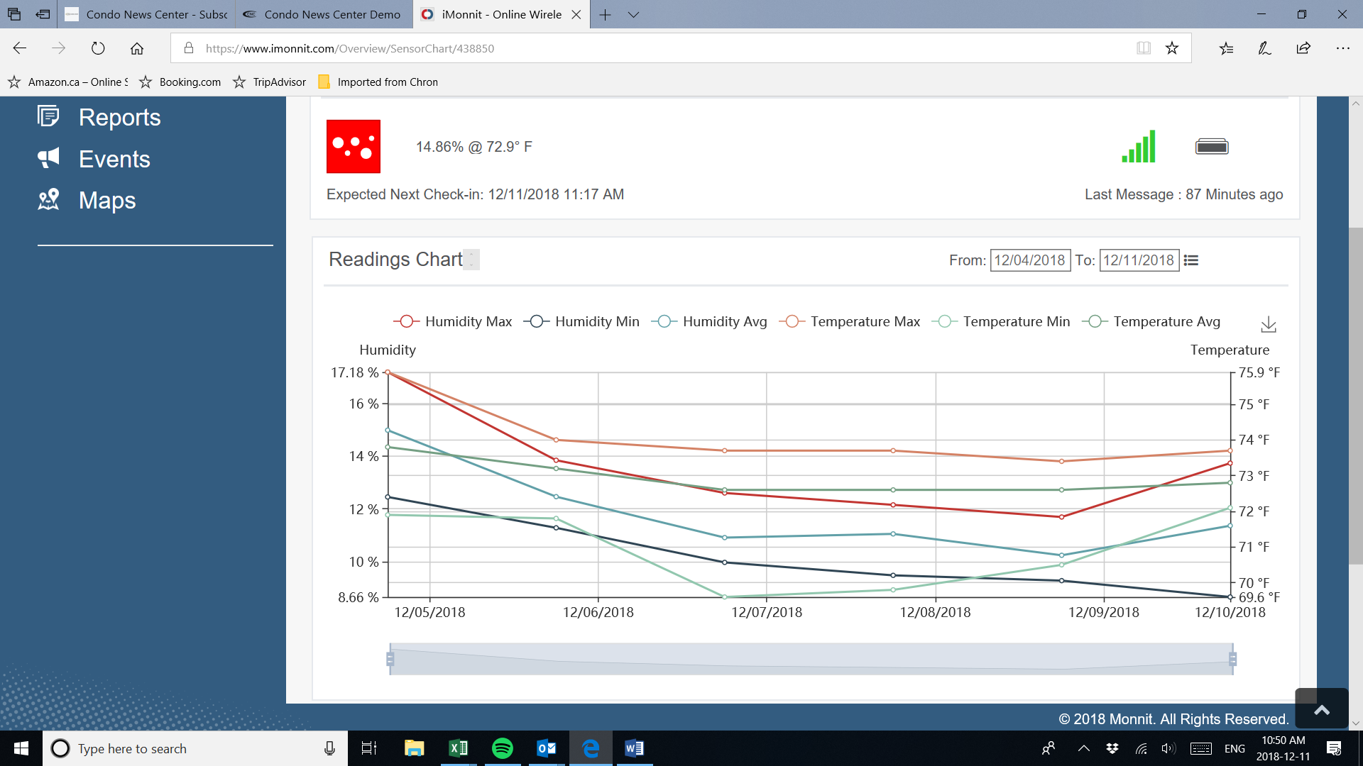

The above humidity readings chart is from a humidity sensor located in a residential unit at Spadina Towers. As you can see, the reading of 8.66% was recorded December 10, 2018. This is extremely low and far less than safe humidity levels. The central humidifier for the residential units was removed a number of years ago simply because the commercial owner claimed humidification was not necessary. The contractor who removed the humidifier advised that the commercial owner directed them to remove the humidifier in order to save money!

This is obviously very detrimental to the health and well being of residents. Humidification must be reinstalled immediately.